CAR INSURANCE

DONE BY:

GRANDHI POOJITHA(R16CS140)

GRACE JULIET JENNIFER(R16CS139)

KOTAPATI SAIMANOJ(R16CS192)

**AIM:**

To build a web application which can be used by a car insurance agency.

**DESCRIPTION:**

It mainly has three sections

1. User
2. Admin
3. Employee

Tasks a user can perform

* Apply for a plan of his choice.
* Renew his insurance.
* Apply for insurance.
* Check his wallet.
* Add money to his wallet.

Tasks an admin can perform

* Add employees.
* View employees.
* View customers.
* Issue an insurance.
* Delete employees.

Task an employee can perform

* Modify status of customers insurance.

**TOOLS:**

FRONT END

* Html
* Css
* Java

BACK END

* mysql

**DATABASE QUERIES**

* select balance from cust where username=?
* update cust set balance=? where username=?
* insert into employee(name,username,password) values(?,?,?)
* delete from employee where name=?

OUTPUTS

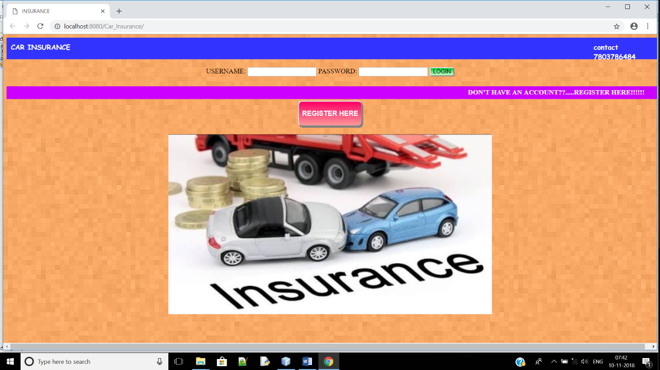

FIG:MAIN USER LOGIN PAGE

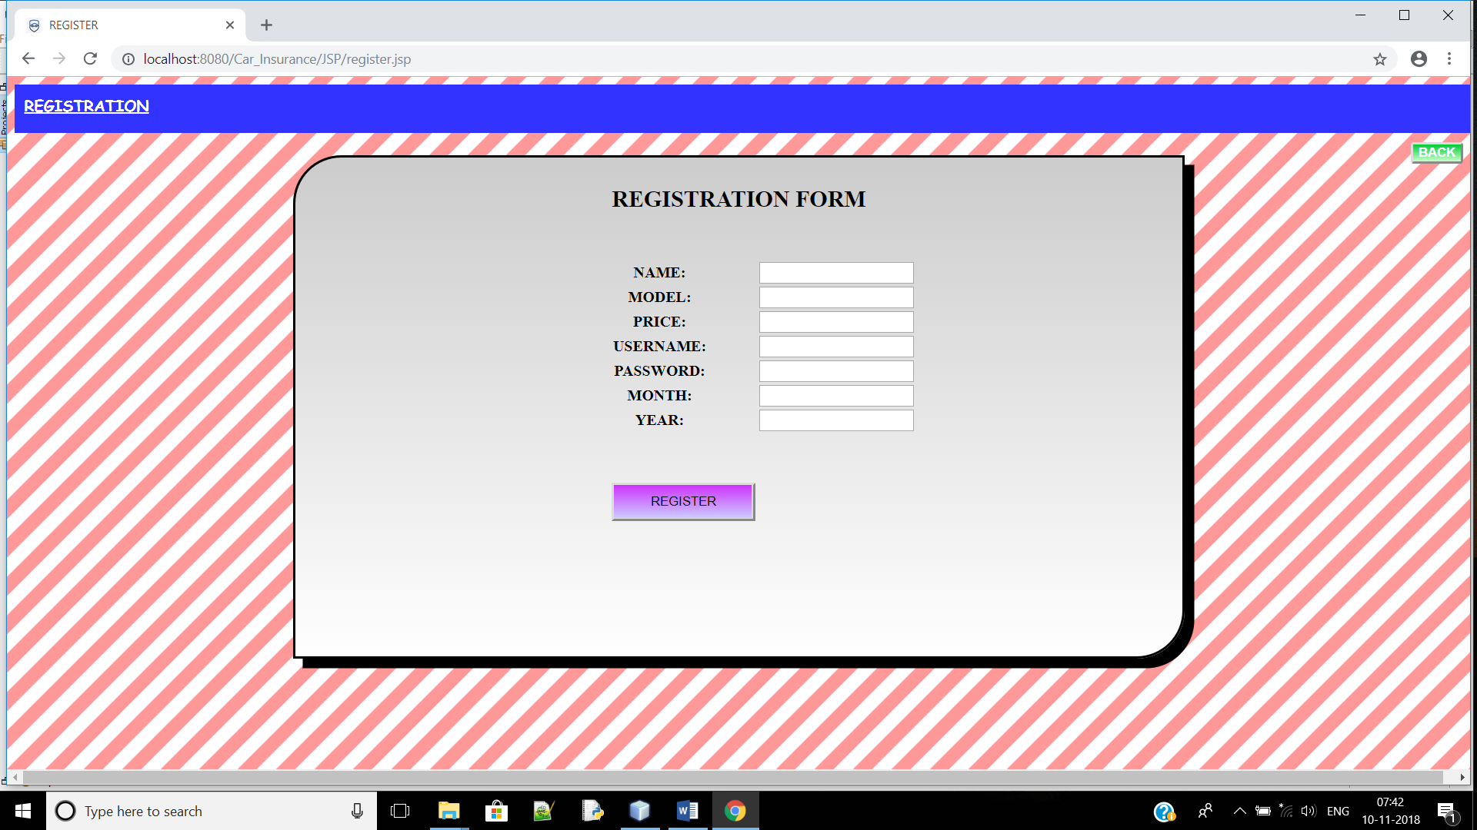

FIG:REGISTRATION PAGE

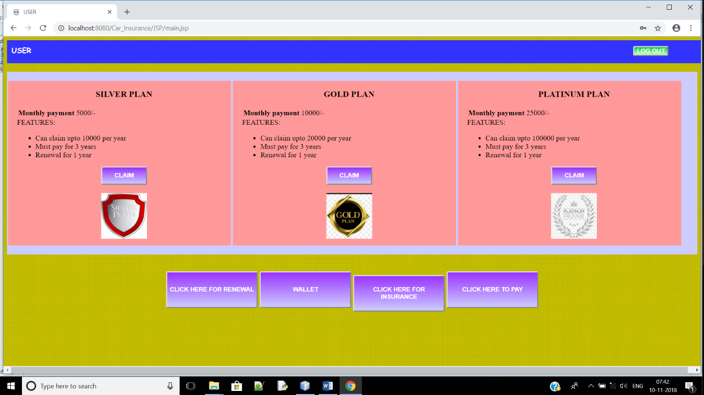

FIG:USER HOME PAGE

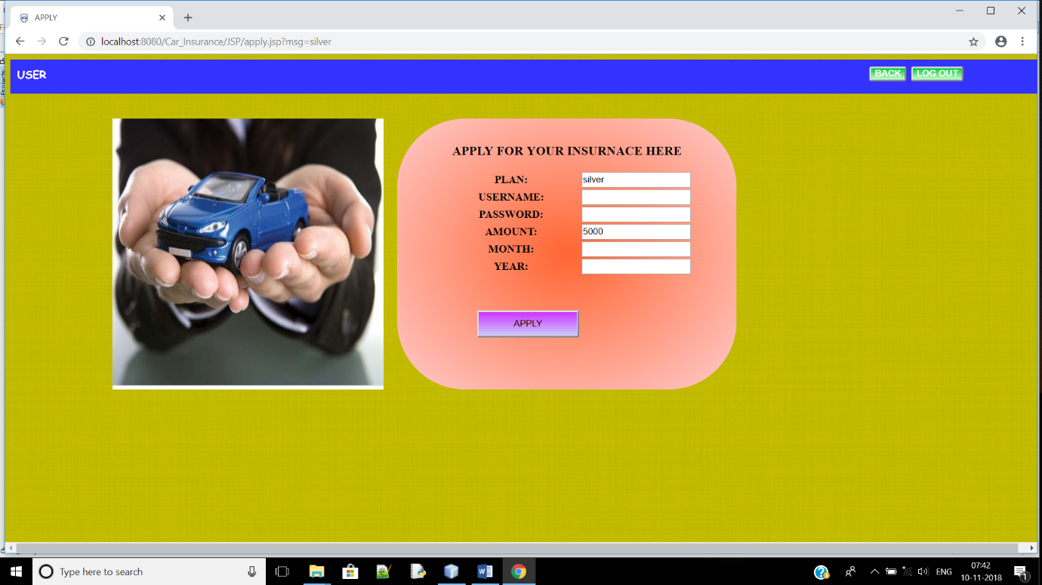

FIG: USER INSURANCE PLAN PAGE

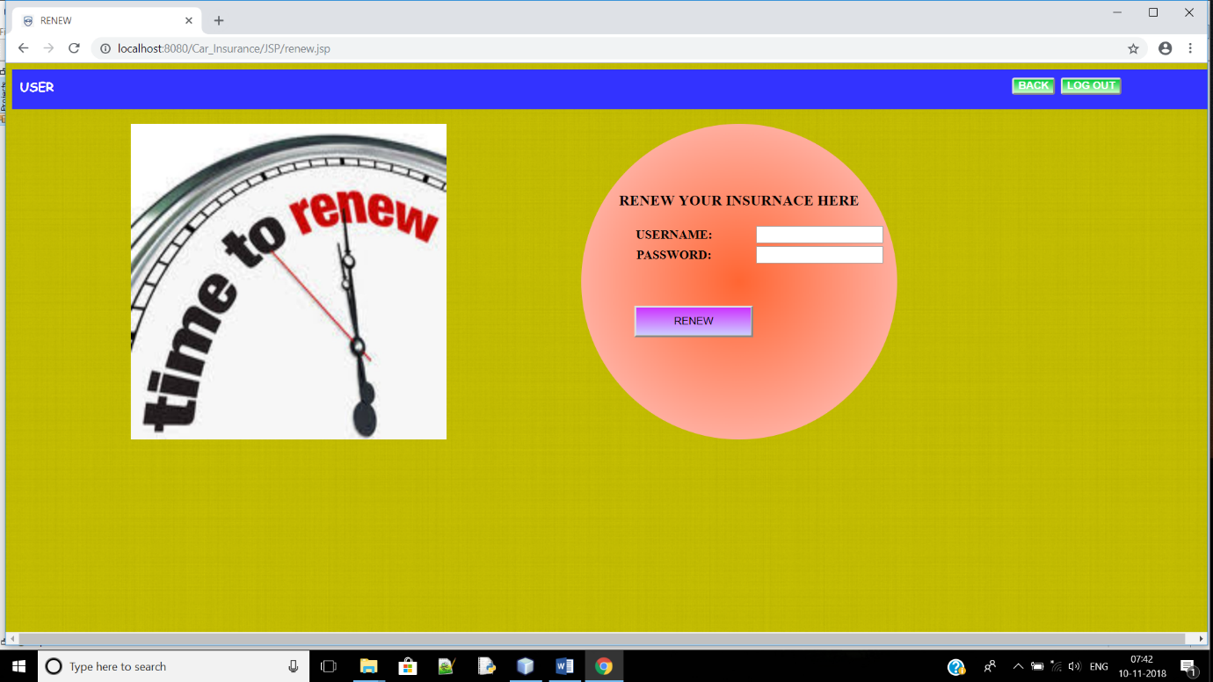

FIG: USER INSURANCE RENEWAL PAGE

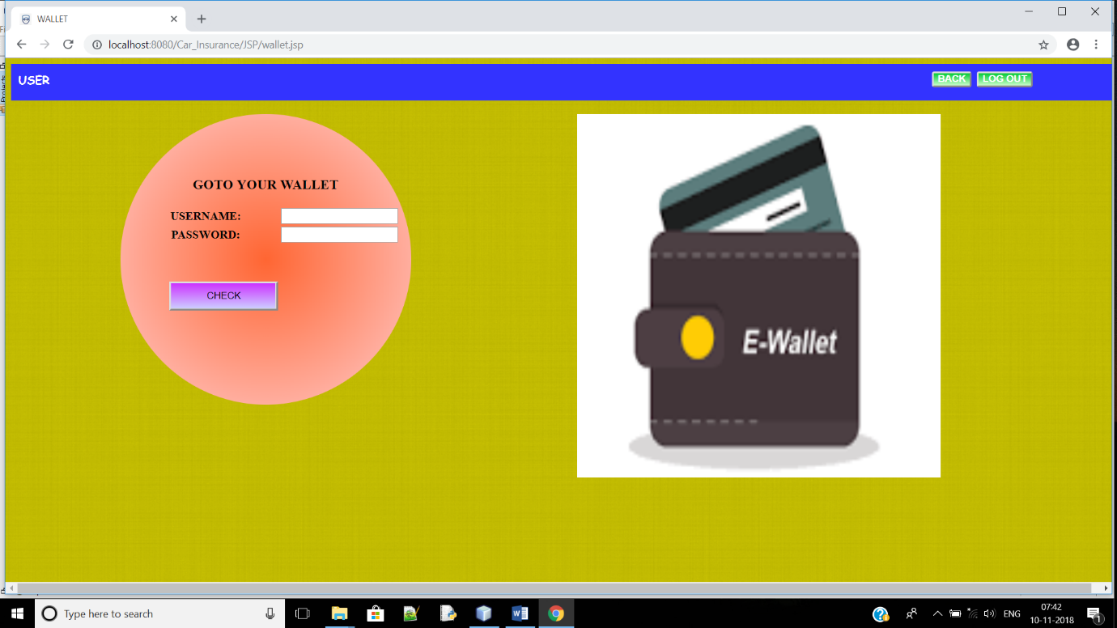FIG: USER WALLET LOGIN PAGE

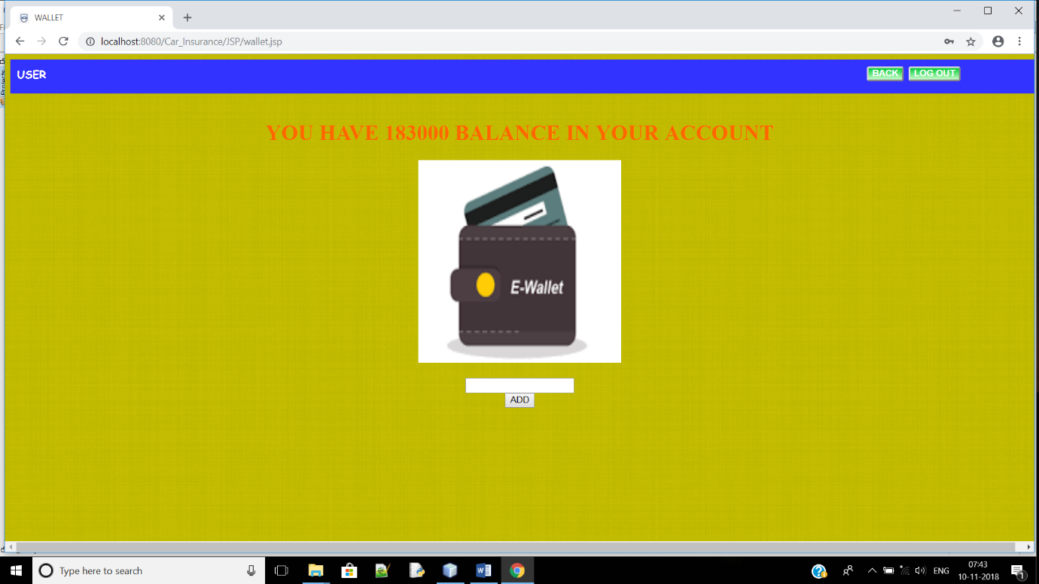

FIG: USER BALANCE PAGE

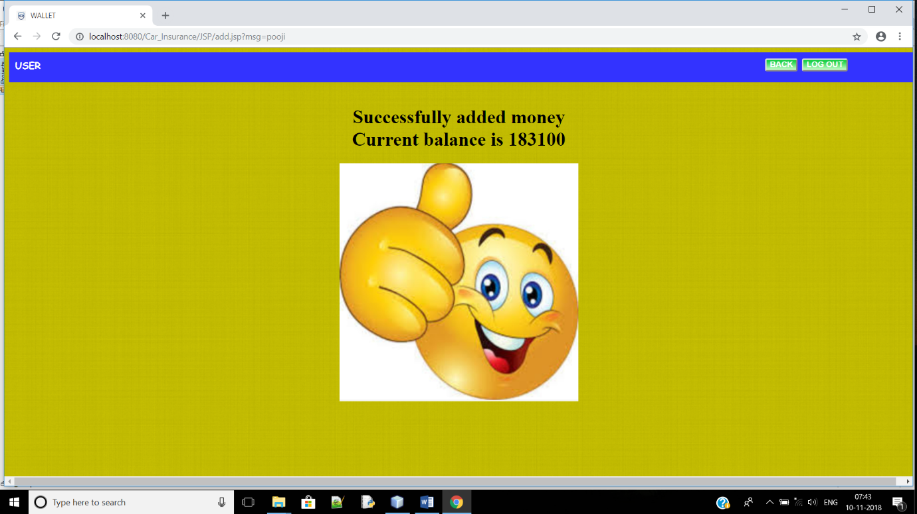

FIG: USER BALANCE UPDATION STATUS PAGE

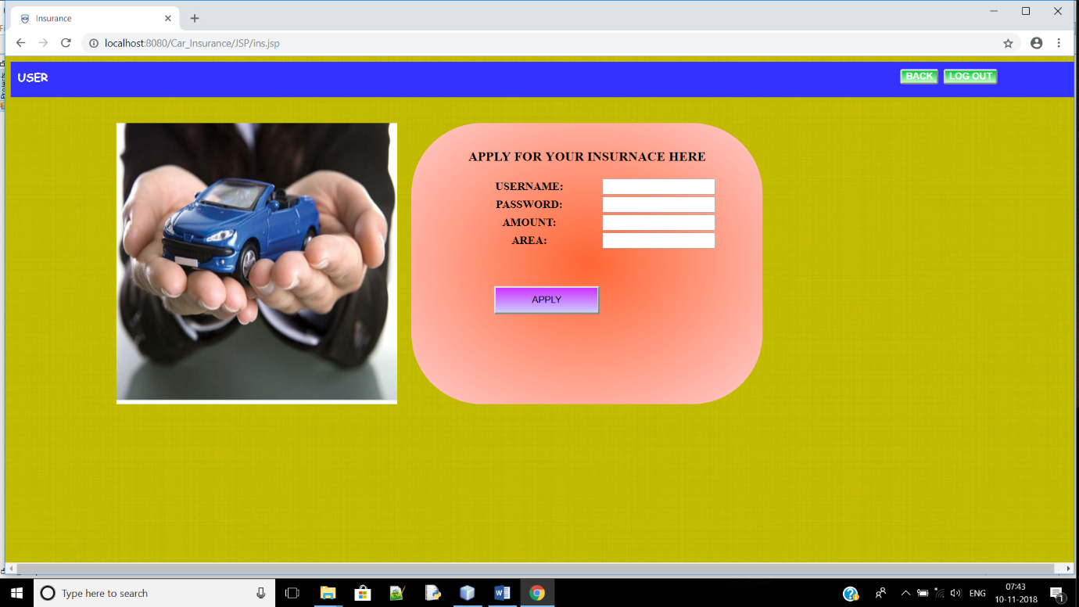

FIG: USER INSURANCE APPLICATION PAGE

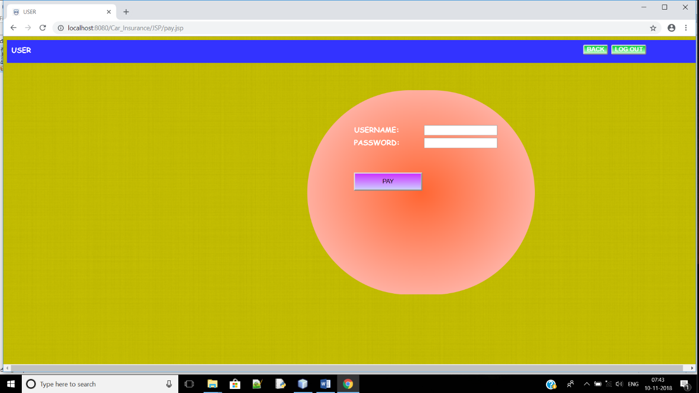

FIG: USER PAYMENT PAGE

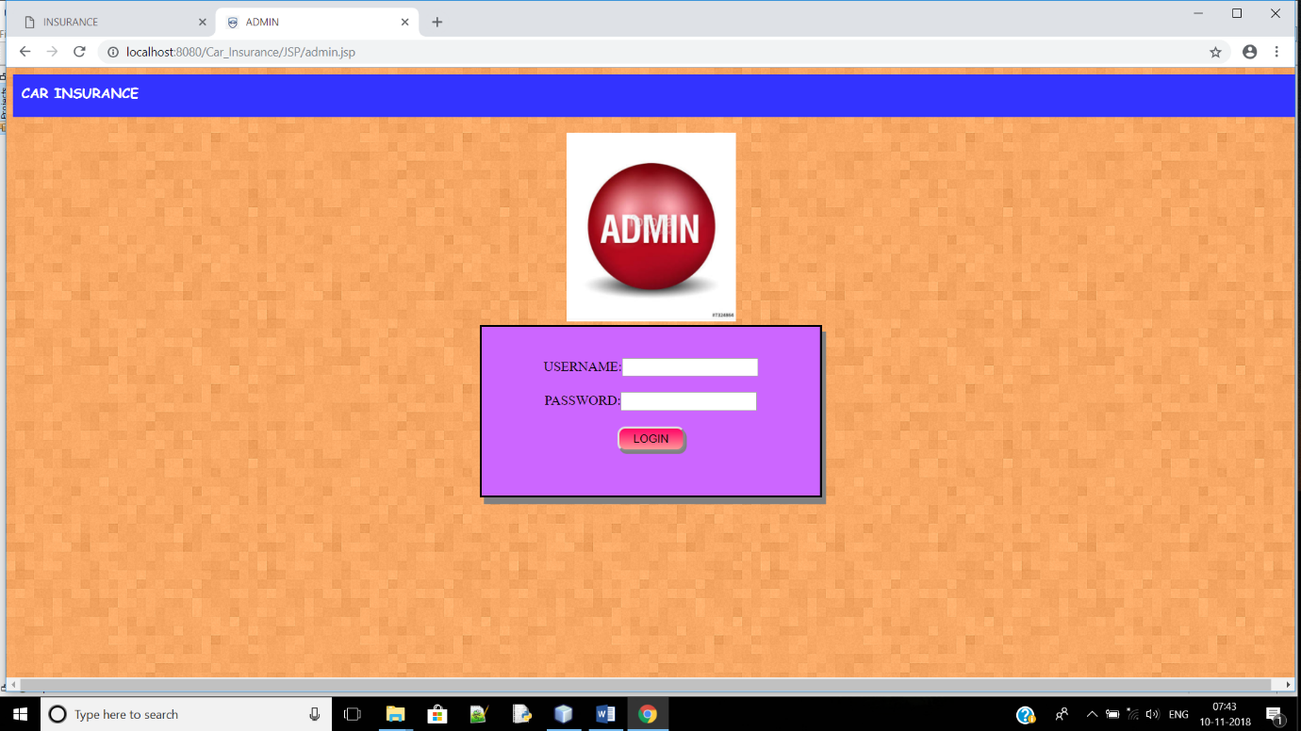

FIG: ADMIN LOGIN PAGE

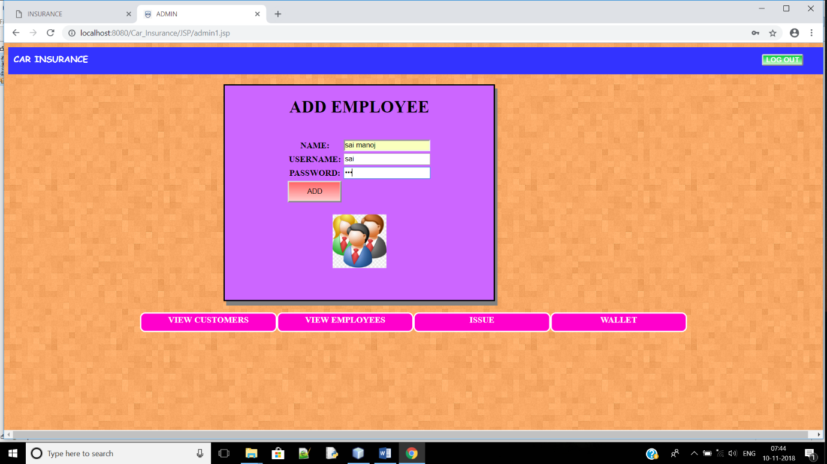

FIG: ADDITION OF EMPLOYEE

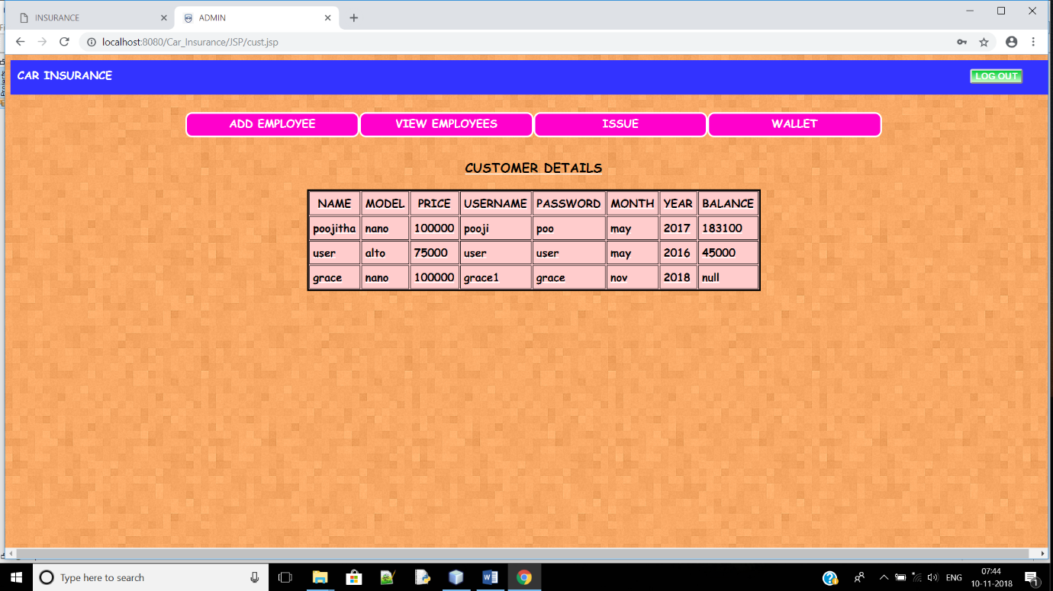

FIG: CUSTOMER DETAILS PAGE

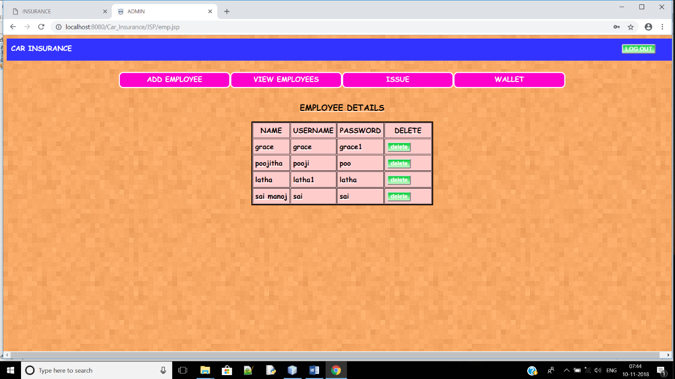

FIG: EMPLOYEE DETAILS PAGE

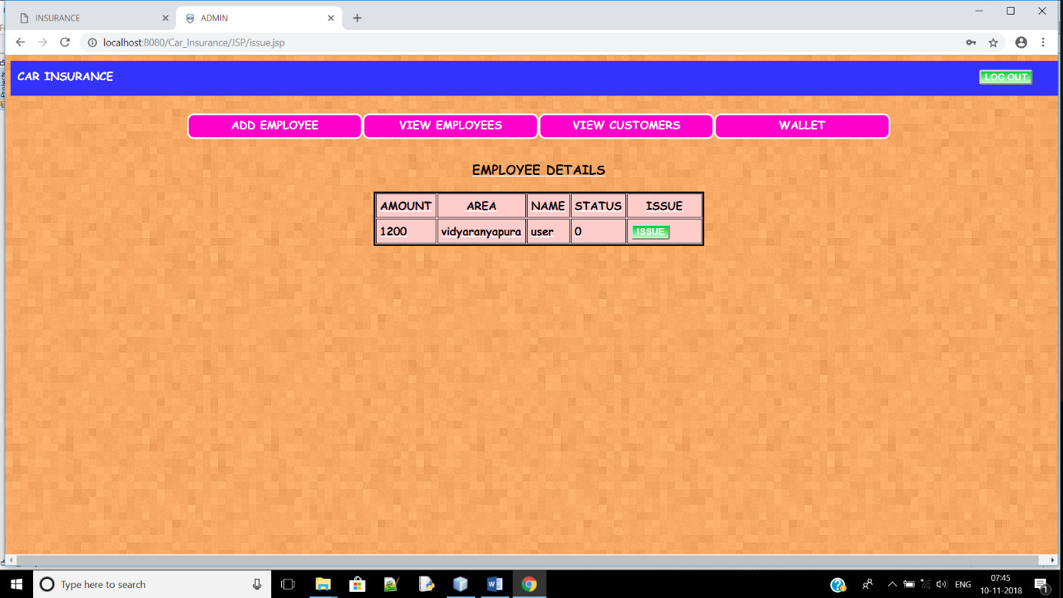

FIG: ISSUE PAGE

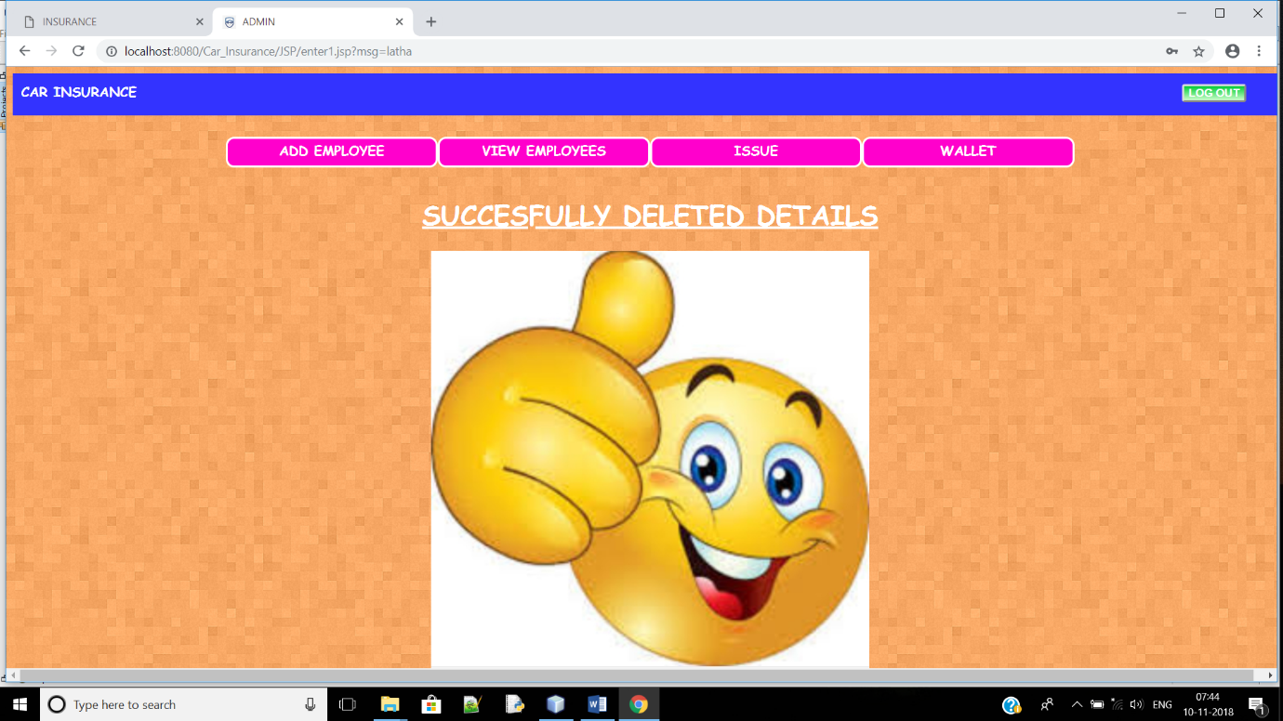

FIG: ISSUE STATUS PAGE

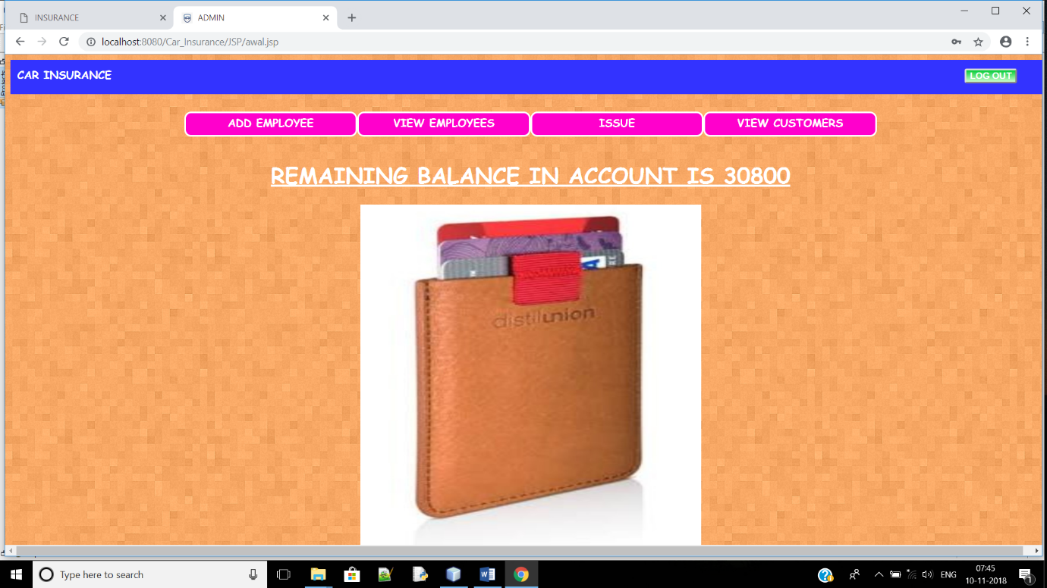

FIG: ADMIN WALLET PAGE

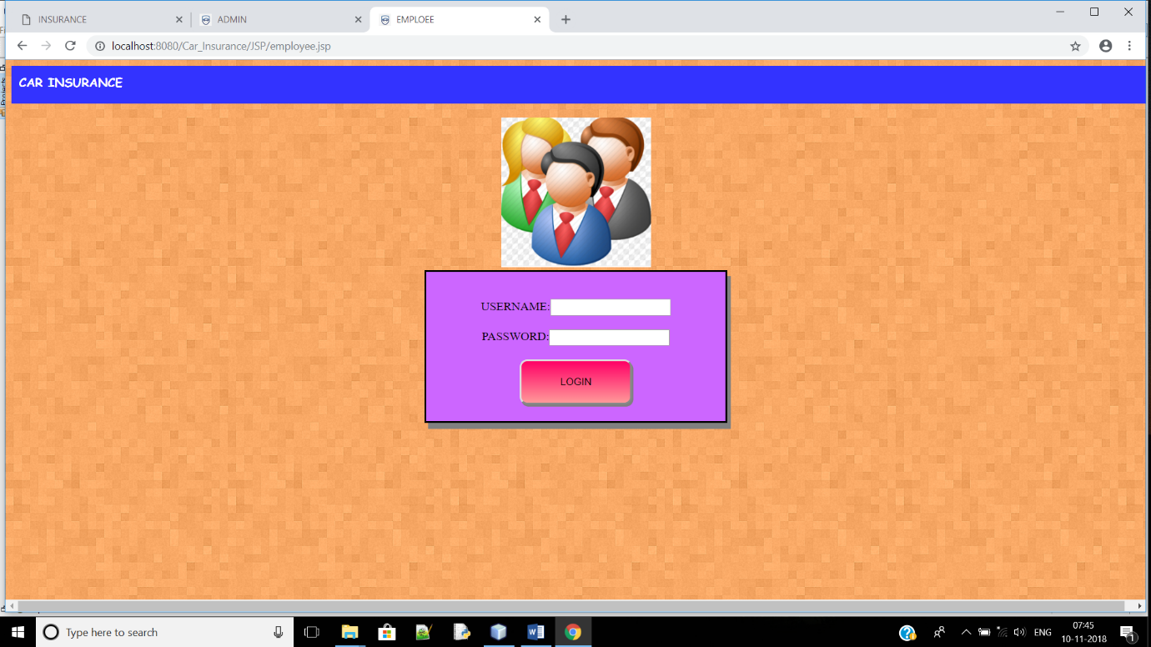

FIG:EMPLOYEE LOGIN PAGE

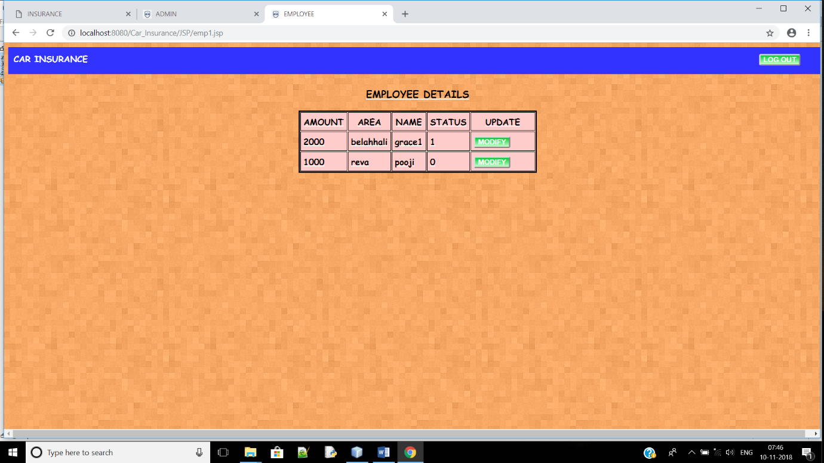

FIG: STATUS MODIFICATION PAGE